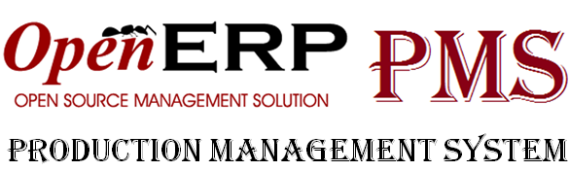

proposal

Version 1.0 on 01/19/2013

Created by PMS Team – K15T – VAN LANG UNIVERSITY

# Revision history

|  |  |  |  |  |
| --- | --- | --- | --- | --- |
| Version | Date | Author | Description | Approved |
| 0.1 | 01/18/2013 | Nghĩa Nguyễn | Create document | Cường Đặng |
| 1.0 | 01/19/2013 | Nghĩa Nguyễn | Approve | Team and Customer |
|  |  |  |  |  |

# List of Contents

Revision history 2

List of Contents 3

List Figure 5

List Table 6

1. INTRODUCTION 7

2. CURRENT PURCHASING MANAGEMENT SYSTEM 8

2.1. Overview 8

2.2. Major Process 8

2.3. Process Flow 9

3. CONCEPT FOR PRODUCTION MANAGEMENT SYSTEM 11

3.1. Overview 11

3.2. Operational policies and constraints 11

3.2.1. Business Policies & Constraints 11

3.2.2. Technical Policies & Constraints 11

3.3. Description of the modified system 12

3.3.1. Open ERP 12

3.3.1.1. Purchase Requisition 12

3.3.1.2. Quotation/ Purchase Order 14

3.3.1.3. Supplier Evaluation 16

3.3.1.4. Create a web account for supplier 20

3.3.2. Open ERP 20

3.3.2.1. Login/Logout 20

3.3.2.2. Account & History Transaction 21

3.3.2.3. Product Management 24

3.3.2.4. Change Request Management 26

3.3.2.5. Multi Language 28

# List Figure

Figure 1: Purchase Management Flowchart 8

Figure 2 : Proposal Feature System 10

Figure 3 : Business Contraints 10

Figure 4 : Technical Contraints 11

Figure 5 : Purchase Requisition List 12

Figure 6 : Purchase Requisition Detail 12

Figure 7 : Choose Supplier from Purchase Requisition 13

Figure 8 : Quotations/ Purchase Orders Management 14

Figure 9 : Detail Quotation/ Purchase Order 14

Figure 10 : Rule Managment 15

Figure 11 : Detail Rule Information 16

Figure 12 : Criteria Management 16

Figure 13 : Detail Criteria Information 17

Figure 14 : Evaluation Managment 17

Figure 15 : Detail Evaluation Information 18

Figure 16 : Information of Detail Evaluation 18

Figure 17 : Create Web Account for Supplier 19

Figure 18 : Login Web 20

Figure 19 : Account Information 21

Figure 20 : Update Account Information 22

Figure 21 : Change Password 22

Figure 22 : Detail Order 23

Figure 23 : Product/ Product Category List 24

Figure 24 : Add new Product 25

Figure 25 : Detail Product Information 25

Figure 26 : Manage Change Request 26

Figure 27 : Detail Change Information 27

# List Table

**No table of figures entries found.**

Name convention of table:

[Table] [Number][.] [Name of table]

Example: Table 1. ABC

# INTRODUCTION

The document describe overview of current information management system for purchasing at DLV Corp, their expectations of software and the characteristics of the proposed solution for purchasing information management system

The intended audience of the Proposal:

* The customer
* Project managers (PMs),
* Project team,
* And any other stakeholders involved in carrying out the project.

# CURRENT PURCHASING MANAGEMENT SYSTEM

## Overview

Founded in late 2008, these following services which DLV provided include:

* DLV Marine: Provide equipment, solutions and maintenance services to the maritime industry, shipbuilding, ports and oil and gas.
* DLV Leisure brokerage sales and leasing yacht comes with retail service tools and sports fishing on the water.
* Ice berry: Manage stores fresh and nutritious foods, including frozen yogurt, smoothies, energy drink (natural energy drink)
* DLV RE: To provide green energy solutions and water purification systems for marine waters and remote islands.
* DLV Home: Providing home appliances: kitchen equipment, heating equipment, home entertainment system.
* DLV Consulting: Providing equipment and consulting solutions for small and medium businesses, CRM ERP system - Enterprise Management, Point Of Sale Software (POS) for restaurant - hotel - supermarket, set be charged, and information technology solutions for hospitals (Smart-hospital).

## Major Process

Overview current purchasing process include step and document which described as following table

|  |  |  |  |
| --- | --- | --- | --- |
| **No.** | **Responsible** | **Flow** | **Reference** |
| 1 | All departments staff | *No*  Approved?  Contact with supplier | Purchase Requisition Order |
| 2 | Chief of departments | *Yes* | Purchase Requisition Order |
| 3 | Purchase Department staff |  | Supplier List |
| 4 | Purchase Department staff | Evaluate supplier | Evaluation Supplier Form |
| 5 | Purchase Department staff | Make a quotation for each supplier | Email  Fax |
| 6 | Purchase Department staff | Compare price/ evaluation point to choose supplier | Price Request Form  Evaluation Supplier Form |
| 7 | Purchase Department staff | Make Purchase Order/ Contract | Purchase Order/ Contract |
| 8 | Purchase Department staff | Update product progress for departments | Track Order Form (P.KD) |
| 9 | Purchase Department staff  Accounting Department staff | Move information of order to accounting department | Purchase Order/ Contract |
| 10 | Purchase Department staff  Store Keeper | No  Receive Product & check quality? | Delivery Order from supplier  packinglist |
| 11 | Store Keeper | Store into warehouse | Incoming Order  Delivery order (for error product) |
| 12 | Purchase Department staff  Accounting Department staff | Pay for supplier | Document, order |
| 13 | Purchase Department staff |  | All of document |

Figure 1: Purchase Management Flowchart

## Description Process

Step 1: All department staffs make the requisitions for purchase department in the company to require some product which they need

Step 2: Chief of departments will confirm the requisitions from their staffs

* If it’s approved, it will be moved to purchase department
* If it’s disapproved, the process will end here.

Step 3: when receiving the requisitions, the purchase department staffs will choose the suitable supplier for order based on supplier list

Step 4: Based on the provided evaluation order which include criteria & rule, the purchase department staffs will conduct the assessment for supplier.

Step 5: The purchase department staffs require the suppliers to send quotation via email or fax

Step 6: Based on the price list sent from supplier & evaluation point, the purchase department staffs will conduct to compare supplier with each other in order to choose the most suitable supplier.

Step 7: Once the supplier has been choosen, the purchase department staff will sign a contract with this supplier.

Step 8: The purchase department staff will update the progress of goods moving for department which required the product

Step 9: The purchase department staff will transfer information to the accounting department staff in order to pay or advance the orders for suppliers

Step 10:

* If the goods meet the quality & quantity as in contract (purchase order), the department staff will ask the store keeper to allow moving goods into the warehouse
* If the goods are poor quality or missing quantity, the department staff will confirm with the supplier and make delivery order to supplier (if any)

Step 11: The store keeper will move goods with ensure quality into the warehouse and export the goods with error for supplier

Step 12: The accounting department staff track the purchase order and make invoice to pay for supplier as in contract

Step 13: The purchase department staff store all of document about this transaction to report and re-evaluate supplier.

# CONCEPT FOR PRODUCTION MANAGEMENT SYSTEM

## Overview

Production Management System (PMS) allows DLV Corp to manage the operation of its business from the requisition management, handling purchasing operations, monitoring and update the status of your purchase orders that required delivery to and paid for suppliers

Figure 2 : Proposal Feature System

## Operational policies and constraints

These following tables describe operational policies and constraints that apply to the new or modified system.

## Business Policies & Constraints

|  |  |  |
| --- | --- | --- |
| ID | CONSTRAINT NAME | CONSTRAINT DESCRIPTION |
| C.06 | Resources limitation | Human resource are 6 people |
| C.07 | Time limitation | The schedule is in 3 months |

Table 1: Business Constraints

## Technical Policies & Constraints

|  |  |  |
| --- | --- | --- |
| ID | CONSTRAINT NAME | CONSTRAINT DESCRIPTION |
| TC.01 | Run on Platform | Running on  Ubuntu, Web-based application |
| TC.02 | Network | Using Internet with supported browser |
| TC.03 | Implementation language | Python, XML |
| TC.04 | Development platform | MVC, eclipse , Openerp |
| TC.05 | Database | Postgres SQL |

Table 2: Technical Constraints

## Description of the modified system

The PMS system includes theses following feature:

## Open ERP

## Purchase Requisition

The feature manage all purchase requisition from all department staff for purchase department to ask some product which they need.

In creating requisition process, the feature support:

* Allow all department staffs creating the requisitions for purchase department to ask some products which they need.
* Allow chief of each departments will confirm the requisitions from their staffs
  + If it’s approved, the purchase department staff can see it and start to do quotation
  + If it’s disapproved, the process will end here
* Allow the purchase department staffs add new quotation from requisition
* Allow the purchase department staffs choose the suitable supplier for order based on supplier list.

Some following mockup screen is captured to refer

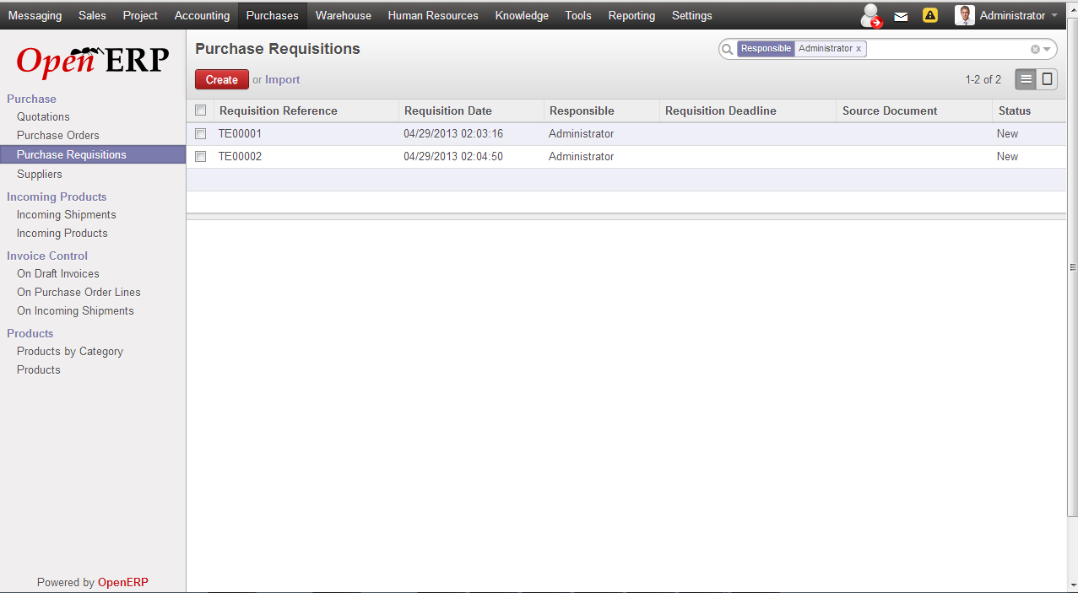

Figure 3 : Purchase Requisition List

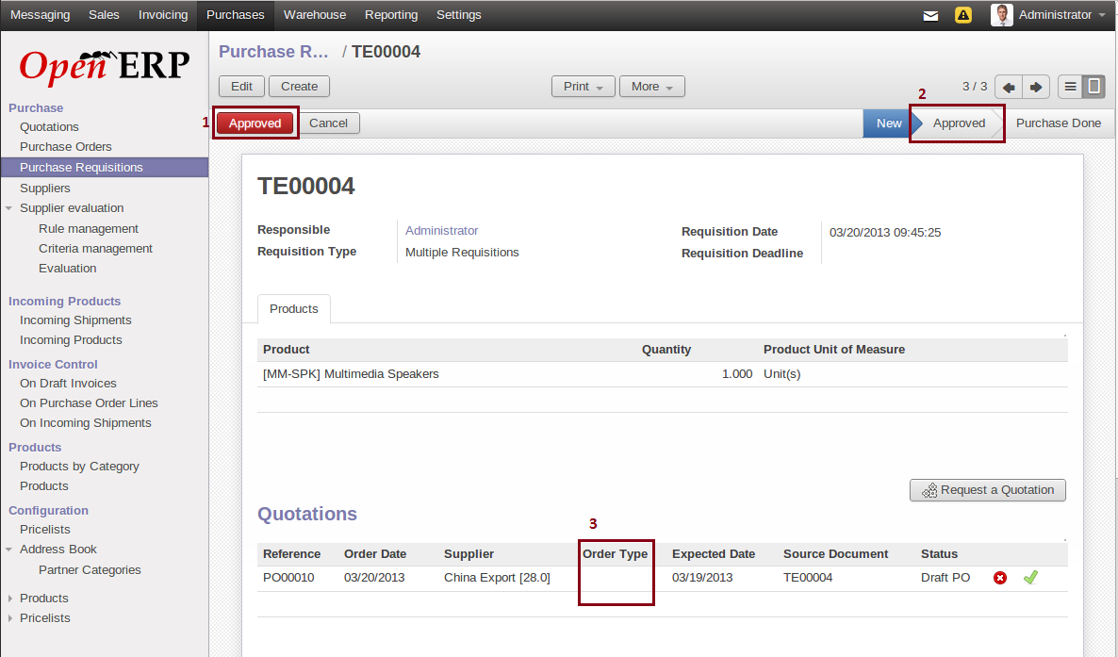

Figure 4 : Purchase Requisition Detail

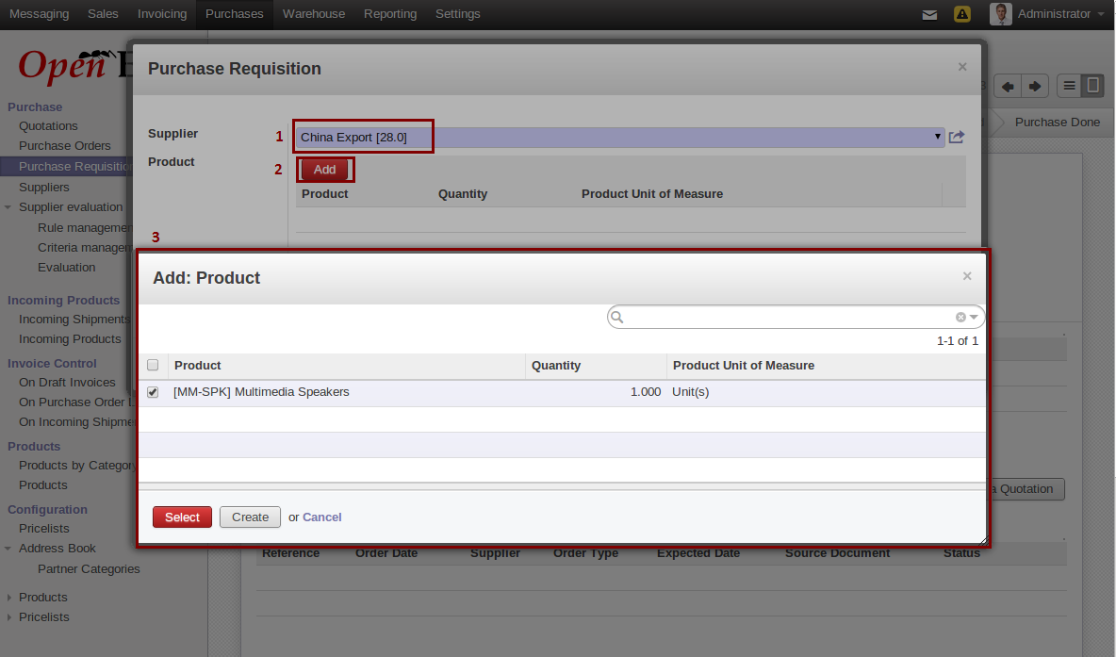

Figure 5 : Choose Supplier from Purchase Requisition

## Quotation/ Purchase Order

The feature allow purchase department staff make a quotation for supplier. Every time quotation is adjust and confirm with supplier, the program provide some status of quotation to help purchase department staff track transaction with supplier

The process of making and adjusting quotation was supported by feature:

* Allow purchase department staffs select type of order such as Importing or Domestic depending on kind of product and geography location of supplier
* Allow purchase department staffs track status of goods based on Track Order
* Allow purchase department staffs add some tax & fee related to transporting the goods for order
* Allow purchase department staffs to print out quotation as PDF file to attach for supplier
* After creating a quotation, the program allow purchase department staffs send e-mail to supplier

Some following mockup screen is captured to refer

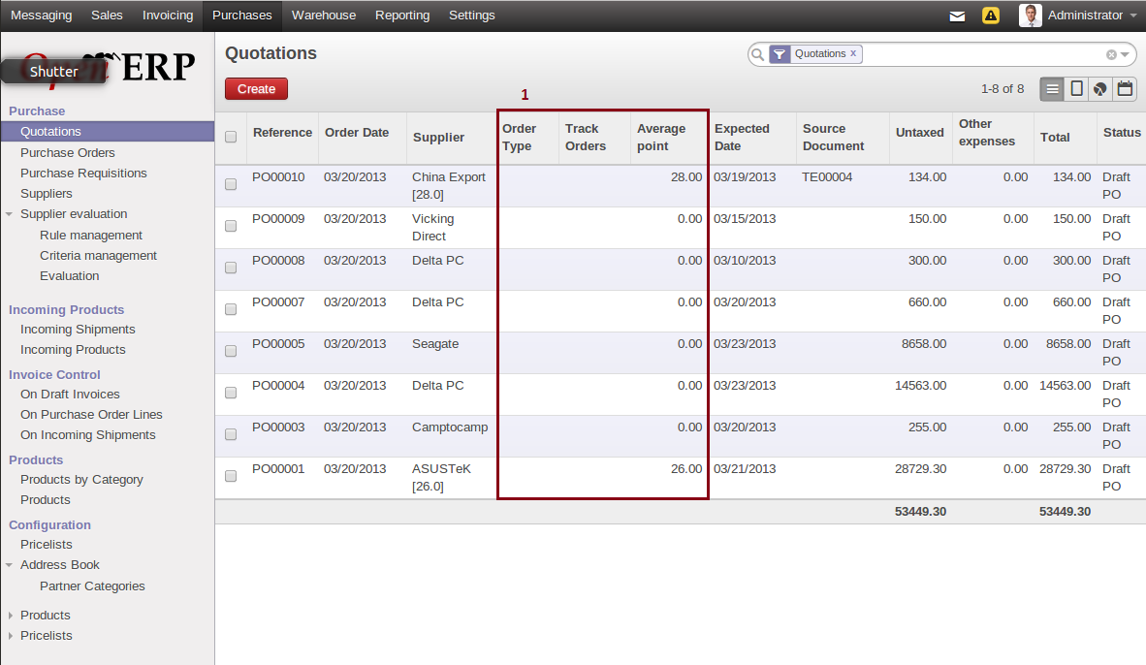

Figure 6 : Quotations/ Purchase Orders Management

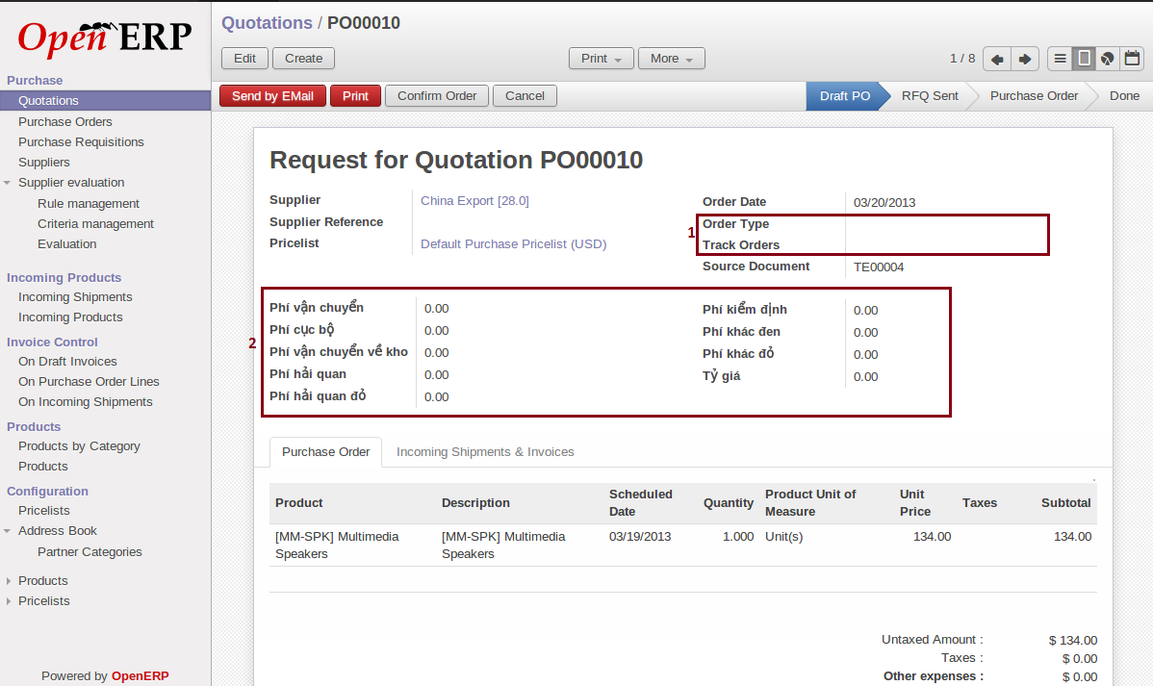

Figure 7 : Detail Quotation/ Purchase Order

## Supplier Evaluation

The feature allows purchase department staffs conduct to evaluate supplier after each transaction. From that, the chief or purchase department staff can refer and make decision to select suitable supplier based on it

* Allow purchase department staff manage and create a rule or criteria for evaluating supplier
* Allow purchase department staff make a new evaluation for supplier after each transaction
* Allow chief department can view and approve or disapprove an evaluation. From that, the grade which supplier achieve can be updated into quotation management to support making decision of purchase department staff

Some following mockup screen is captured to refer

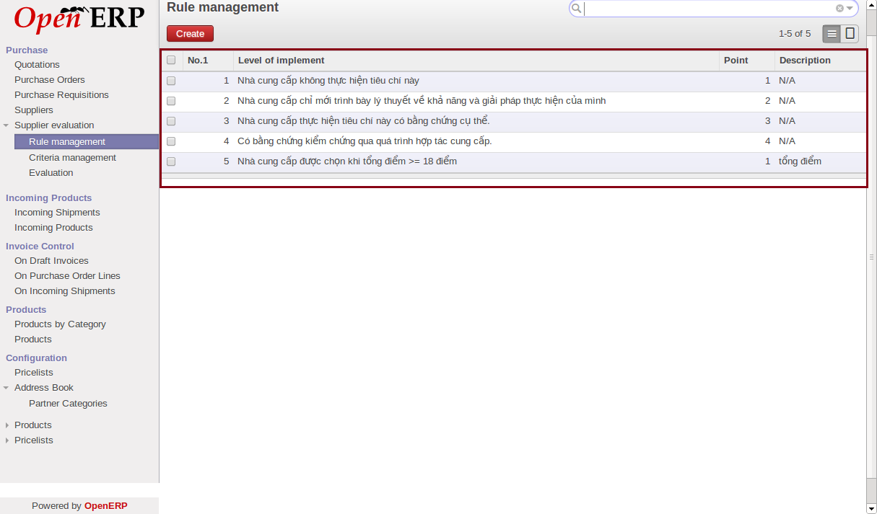

Figure 8 : Rule Managment

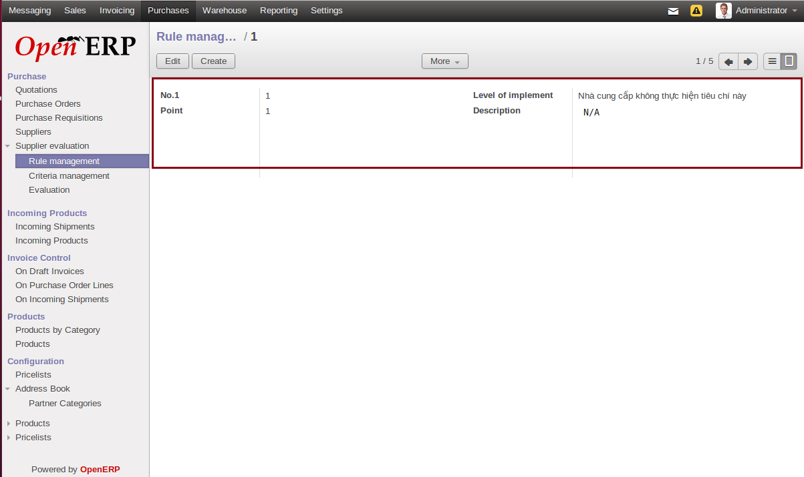

Figure 9 : Detail Rule Information

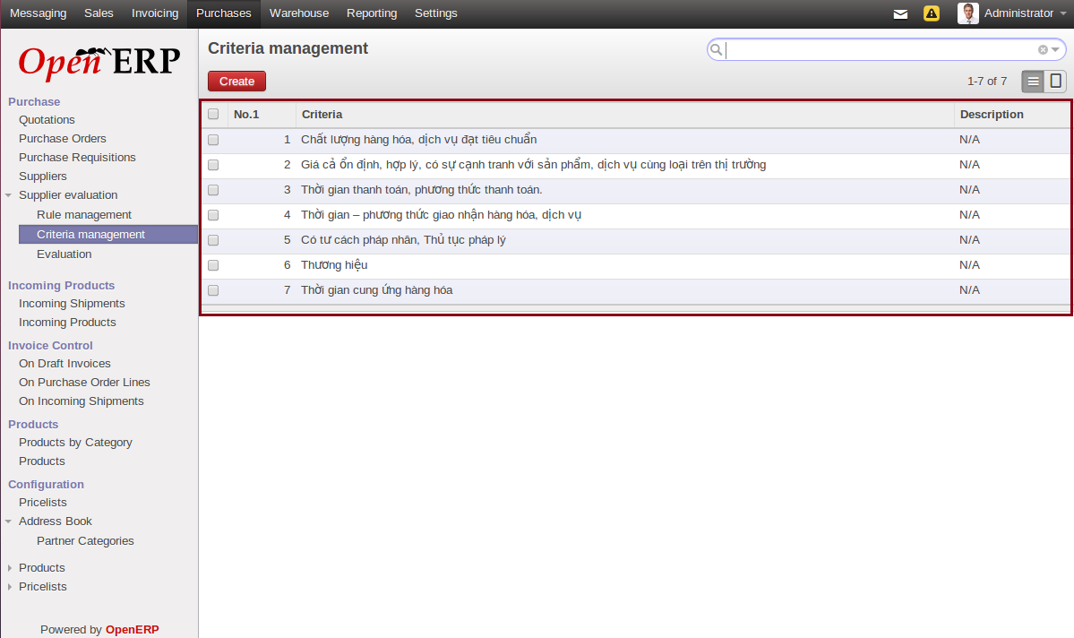

Figure 10 : Criteria Management

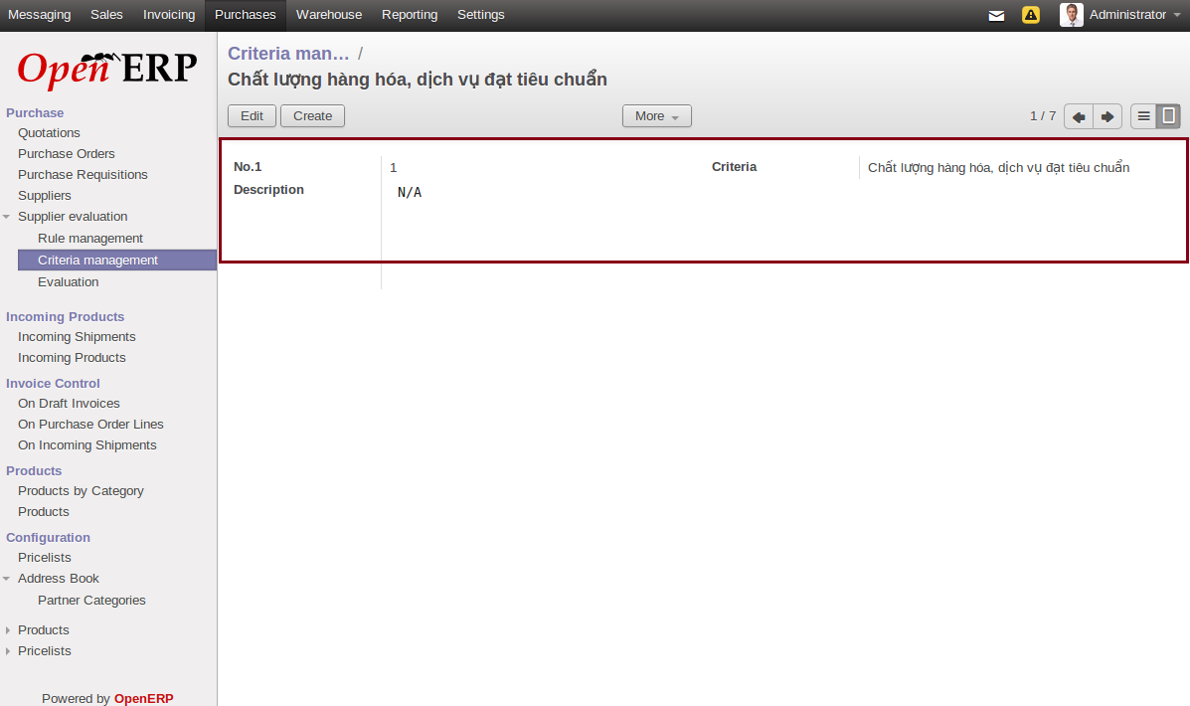

Figure 11 : Detail Criteria Information

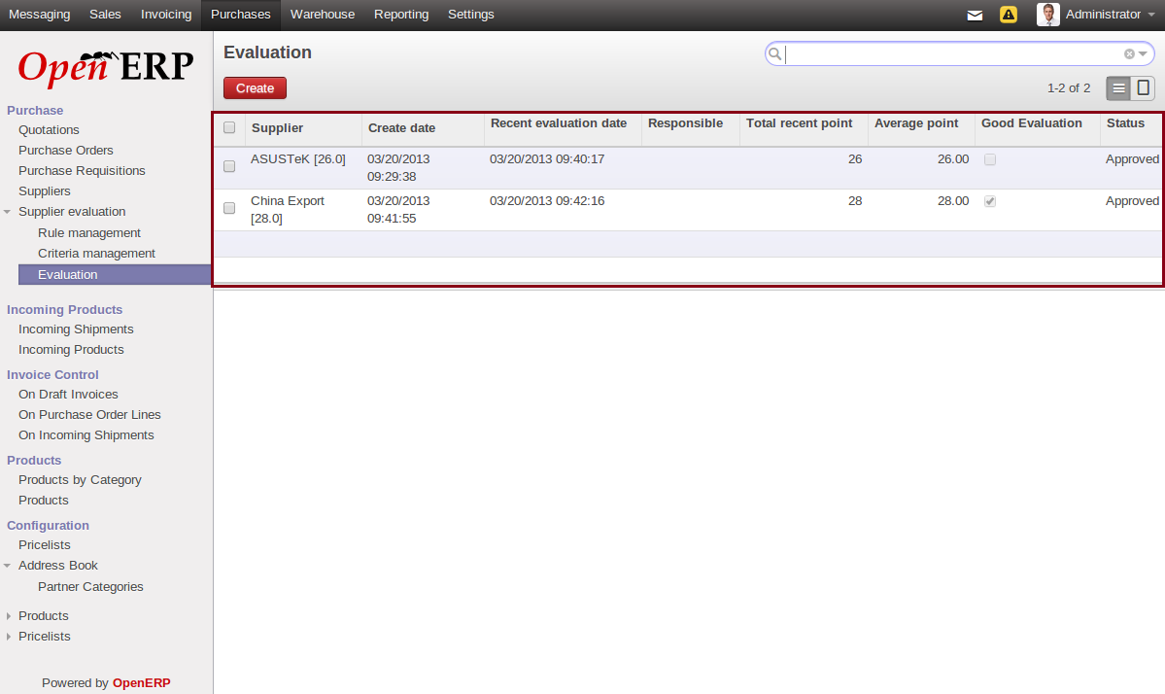

Figure 12 : Evaluation Management

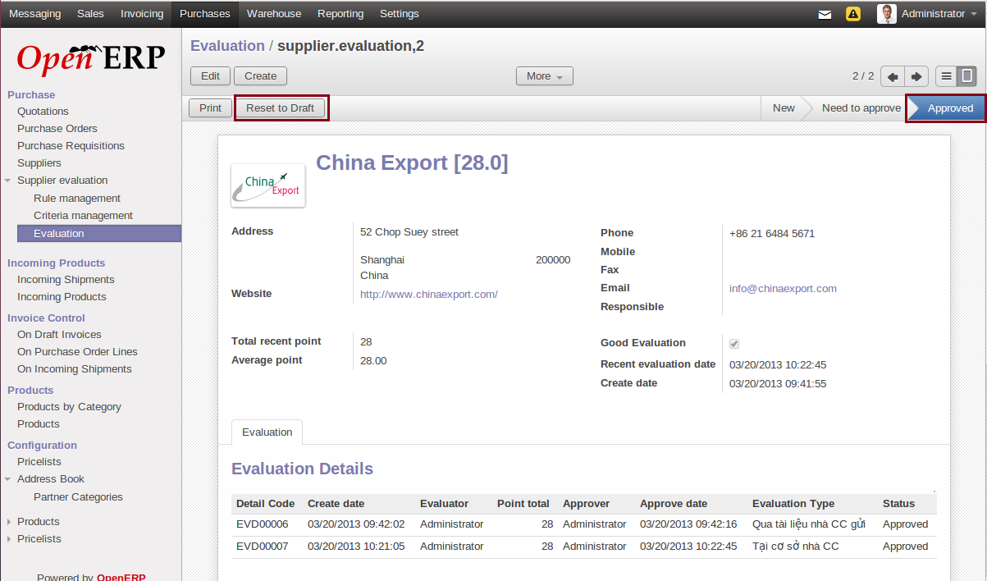

Figure 13 : Detail Evaluation Information

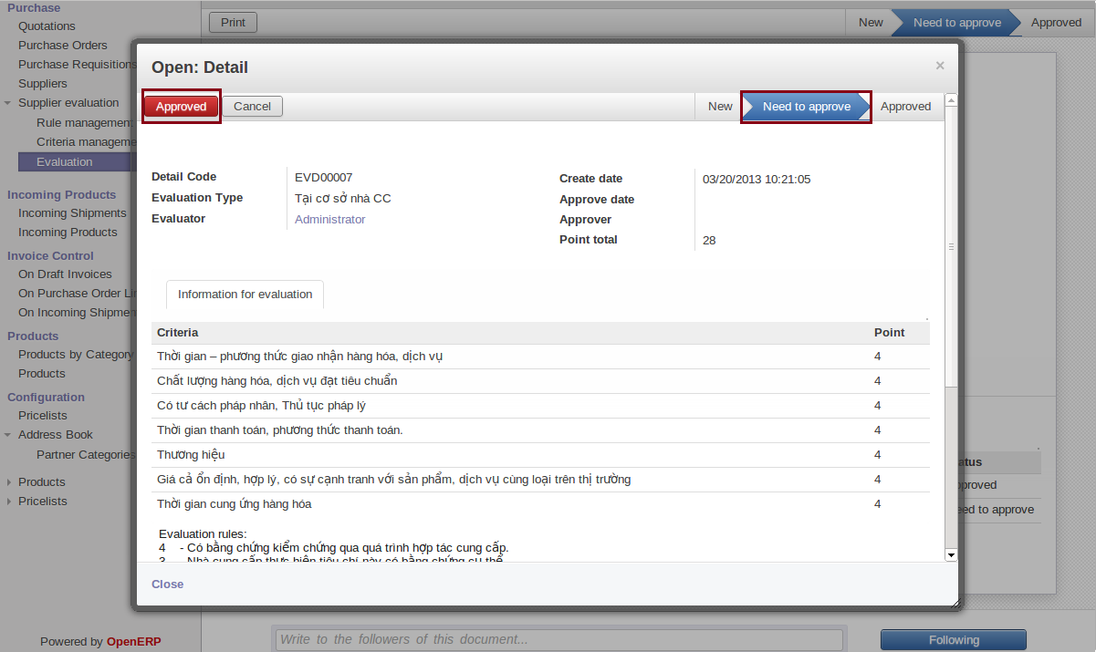

Figure 14 : Information of Detail Evaluation

## Create a web account for supplier

The feature allow purchase department staff an account to access the web for supplier

* Allow purchase department staff create a new account for supplier with default password
* Allow purchase department staff send email to supplier to notify account information
* Allow purchase department staff reset password for supplier account in case they forget their password
* Allow purchase department staff lock/unlock account if necessary

Some following mockup screen is captured to refer

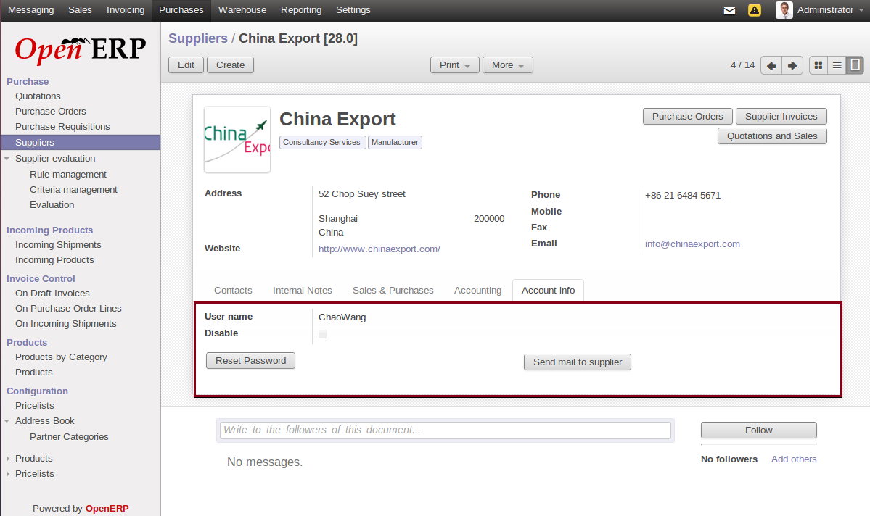

Figure 15 : Create Web Account for Supplier

## Open ERP

## Login/Logout

The feature allow user as supplier access the web to manage providing product and track history transaction

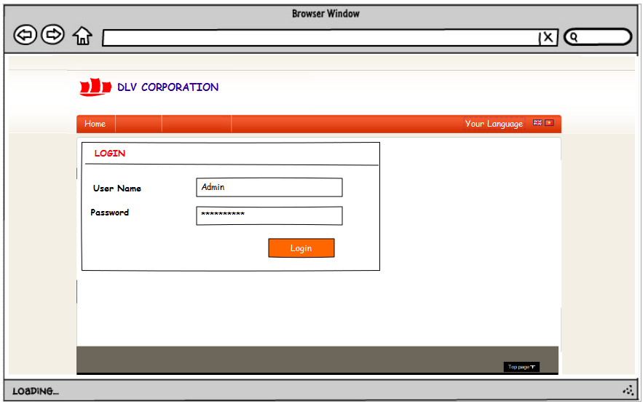

Figure 16 : Login Web

## Account & History Transaction

The feature allow user view account information and history transaction. They also can update their account information and view detail an order from Open ERP

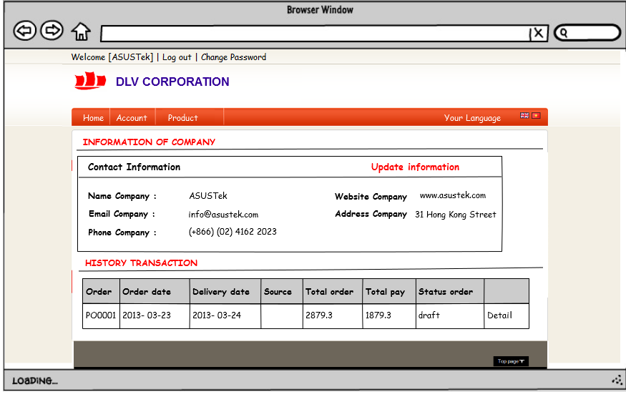

Figure 17 : Account Information

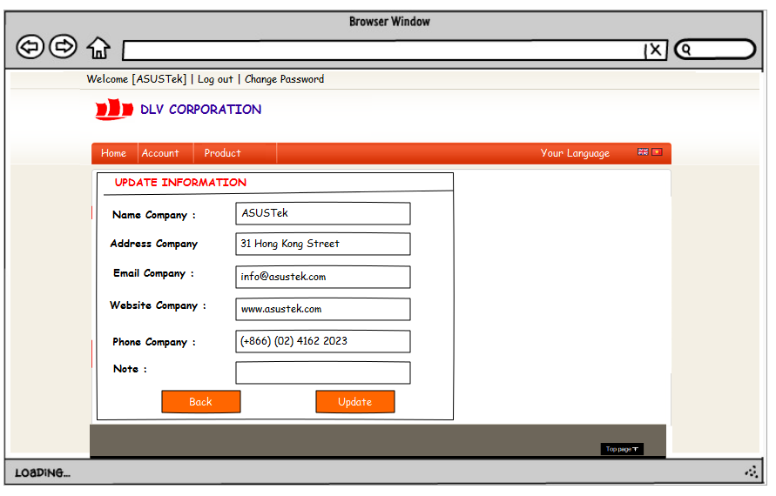**Figure 18 : Update Account Information**

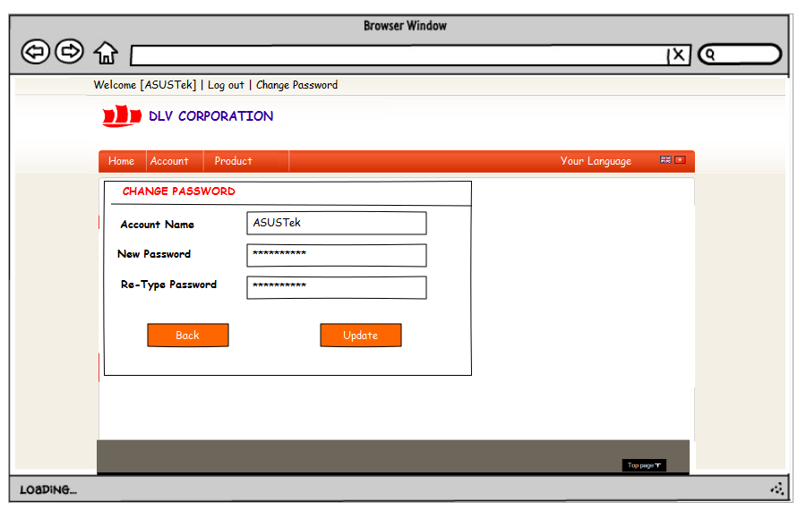

Figure 19 : Change Password

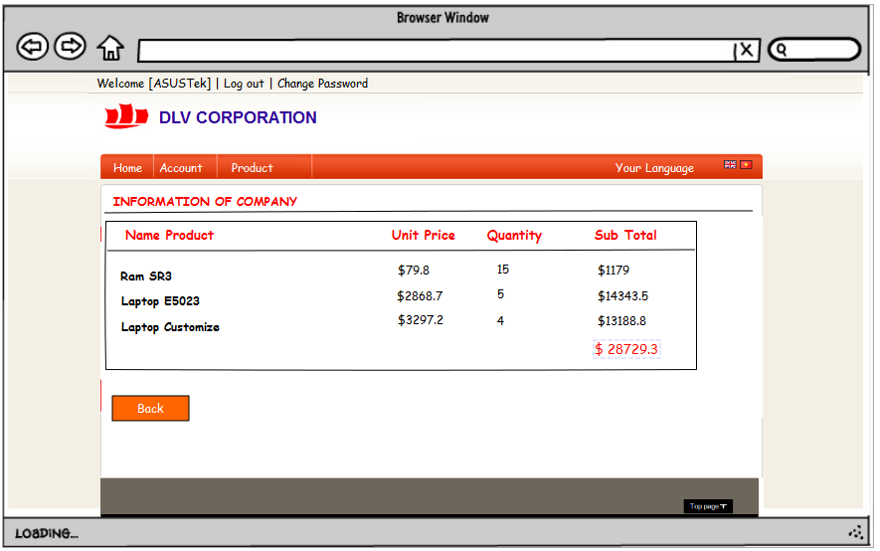**Figure 20 : Detail Order**

## Product Management

The feature allow user manage their product which they are providing by viewing product and product category list. They also create a product they will supply in next time and view detail information of product with price, too.

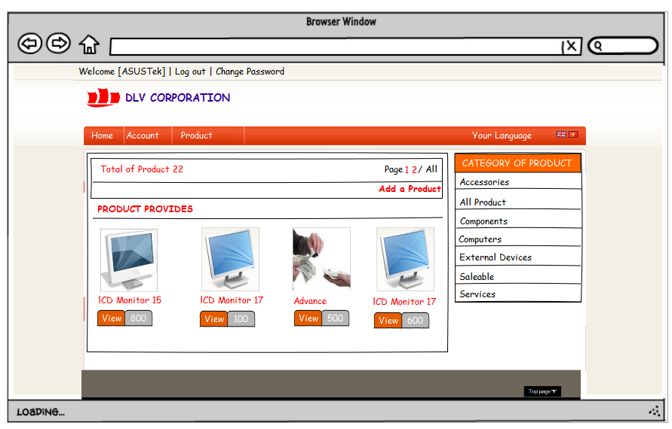

Figure 21 : Product/ Product Category List

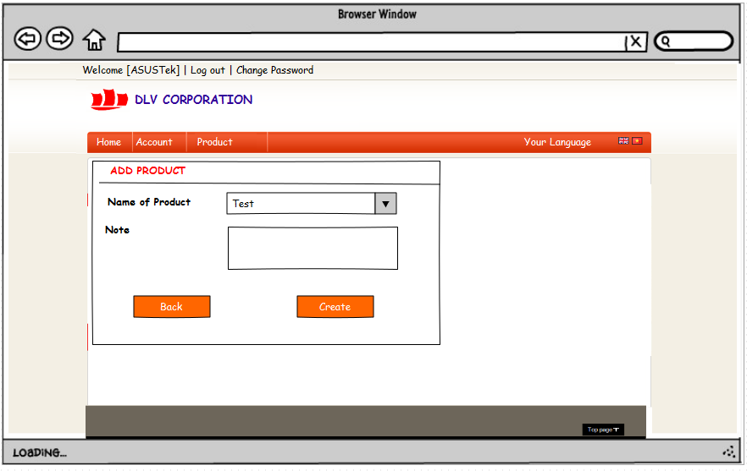**Figure 22 : Add new Product**

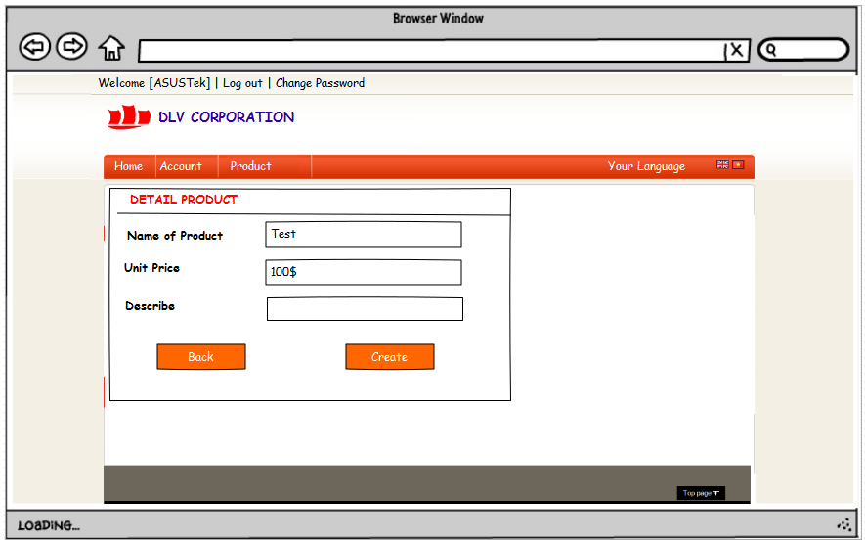

Figure 23 : Detail Product Information

## Change Request Management

The feature allow administrator see the list of change request so that they can select one to view detail information in order to help user know the information more clearly and I can make decision from that. They also approve/ disapprove some change request from supplier to allow this new information can be updated into Open ERP System or not

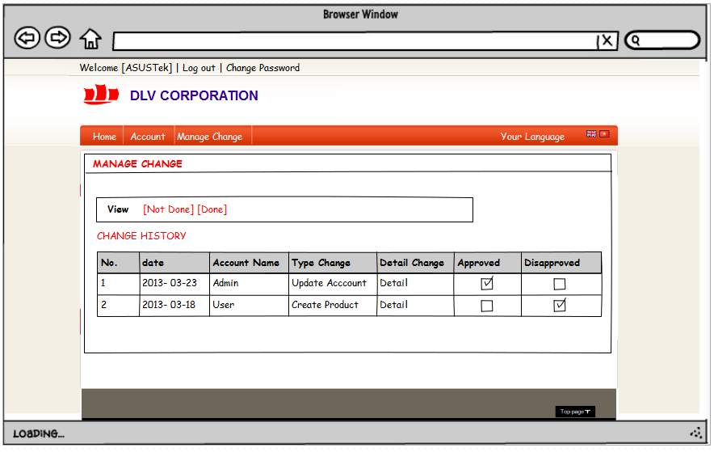

Figure 24 : Manage Change Request

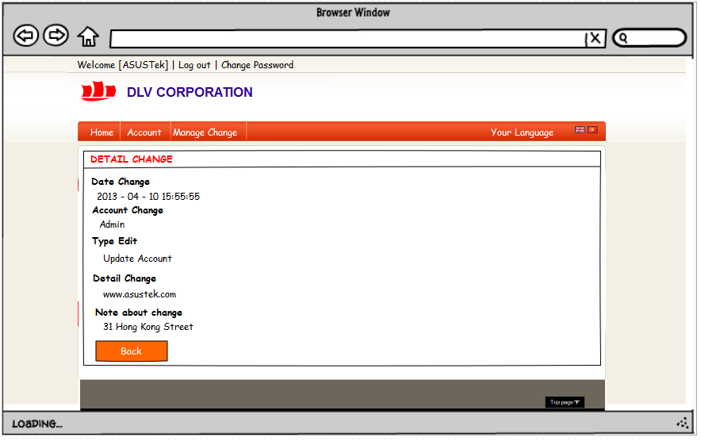**Figure 25 : Detail Change Information**

## Multi Language

The feature support multi language as English or Vietnamese allow user choose the suitable language for them